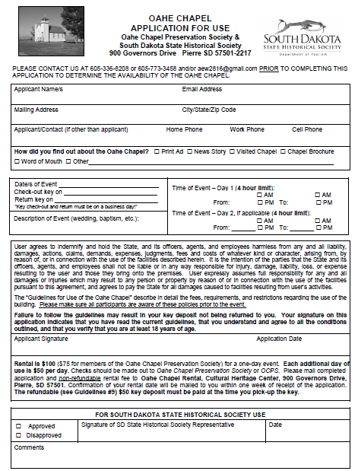

Prior to filling out the application, contact Katie Goss at 605-773-2907 or [katie.goss@state.sd.us](mailto:katie.goss@state.sd.us) to make sure your date is available!